**THE KITSILANO BEACH**

**Kitsilano Beach** is one of the most popular beaches in [Vancouver](https://en.wikipedia.org/wiki/Vancouver), especially in the warm summer months. Located at the north edge of the [Kitsilano](https://en.wikipedia.org/wiki/Kitsilano) neighbourhood, the beach faces out onto [English Bay](https://en.wikipedia.org/wiki/English_Bay_(Vancouver)).

The beach is home to the longest swimming pool in Canada, the salt-water outdoor Kitsilano Pool, operated by the [Vancouver Park Board](https://en.wikipedia.org/wiki/Vancouver_Park_Board) and open annually from May to September.

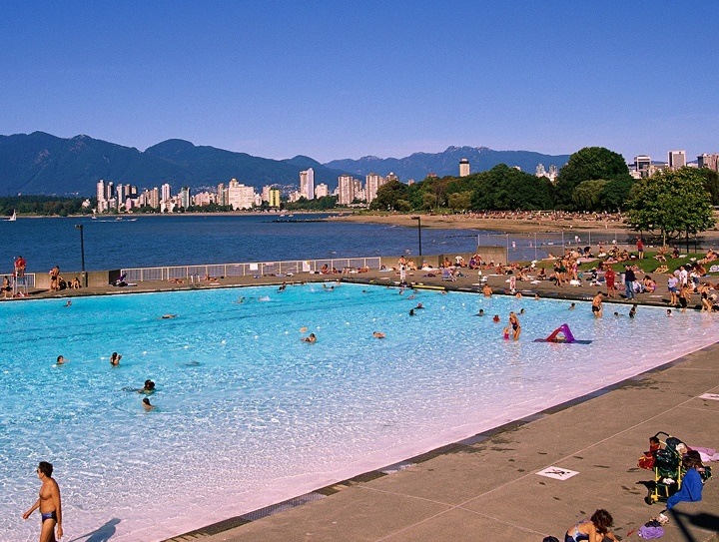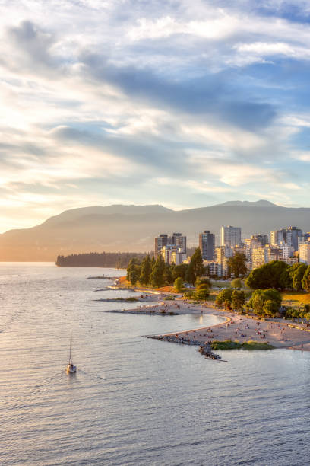

Toward the northern edge of the beach is a [playground](https://en.wikipedia.org/wiki/Playground) and a number of beach volleyball courts. In the [Squamish language](https://en.wikipedia.org/wiki/Squamish_language), it is called *Xwupxpayʼem*, which translates to "having red cedar".